**Ash Creek (West)**- south side of stream, north of parking lot- USFS (trail marker 766), anchored around tree  
N 42.63029, W 103.24501

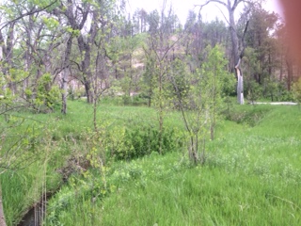

**Ash Creek (East)**- west side of road, below undercut bank, attached to metal stake  
N 42.62372, W 103.18910

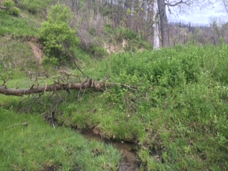

**Bordeaux (North)**- at WMA walk in from parking lot, east side of stream, stake just below tree. 42.809711, 102.922162

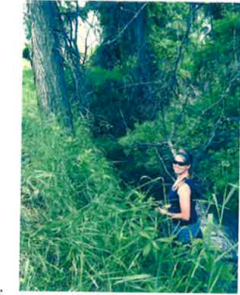

**Bordeaux (Cliffs)**- located near the parking lot, west side of the road, right below the culvert  
42.717783, 102.93040

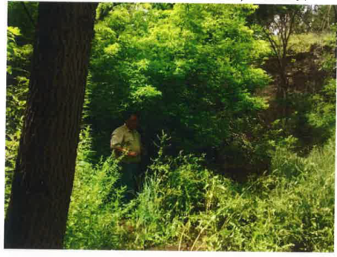

**Chadron Creek (Park Entrance)**- where stream enters park, south side of creek, about 20ft from concrete bridge on Norwesca Rd.  
42.707783, 103.007731

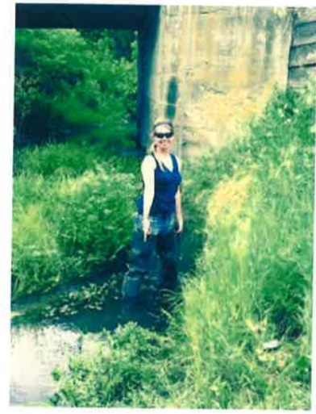

**Chadron Creek (Park Exit)**- park at campsite 23, east side of stream, 5 ft up from boundary ffence  
42.716214, 103.01232

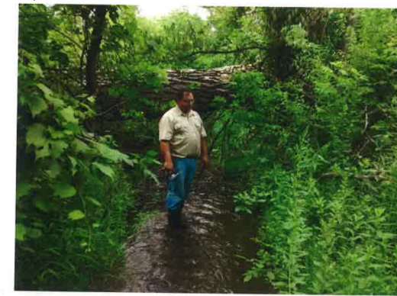

**Chadron Creek (WMA)**- from parking lot, follow cable fence down to creek, logger 40 ft above fence  
42.678702, 102.999026   
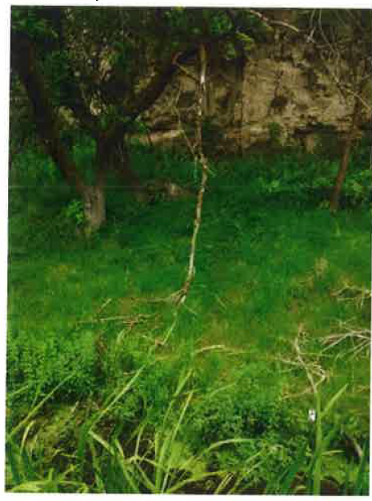

**Chadron Creek** **(Below Discharge)**- cable attached to first large tree, east side of creek, below the inlet.  
42.709515, 103.00951

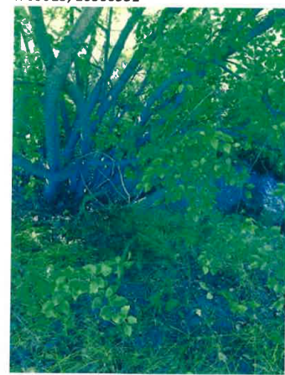

**Chadron Creek (Above Discharge)**- Staked next to first large tree, east side of creek, above the road  
42.709195, 103.009642

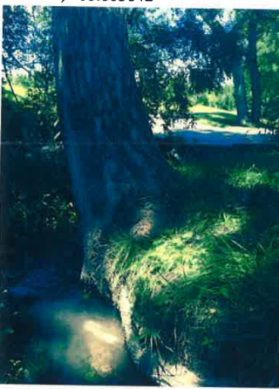

**Deadmans Creek**- below bridge (south side), attached to panel across the stream, middle of Creek  
N 42.62610, W 103.49993

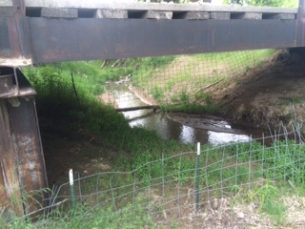

**Monroe Creek**- on Gilbert Bake WMA, approx. 25 yards from campsite parking downstream, in between the fallen cottonwood and where the brush hangs over the stream, opp. Bank from deer lower jaw bone.  
42.76741, 103.92761

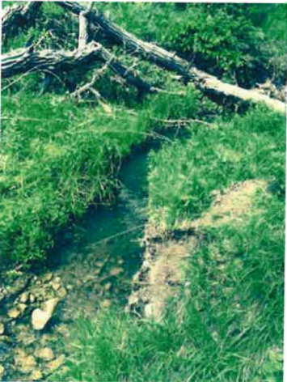

**Nine Mile WMA**- on the 9mile WMA, west side of stream, right above the rock vortex- right above white rive  
41.88858, 103.43400

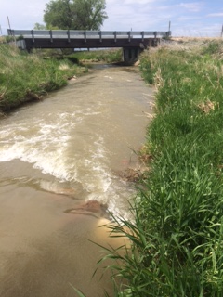

**Nine Mile OFW**- on OFW site, north side of the bridge, east side of stream, wrapped around bridge support.  
41.873452, 103.43721

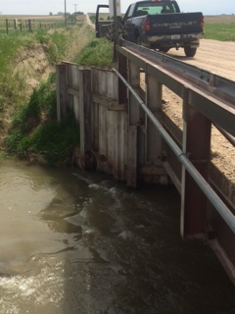

**Niobrara River** **(Hwy 71 Crossing)**- on private land (hunting access) side of fence near white PVC pipe fenceline. Logger stuck near bank, lead line stuck into ground next to H-brace post. **Found right below white vertical stake,** East side of hwy, south side of river  
42.42727, 103.30840

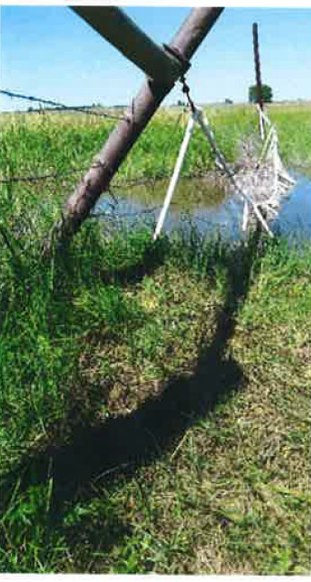

**Niobrara River (Hwy 385 Ansley Fence)**- located on private side of fence line attached to the fence crossing river on 2nd wire from top. Has a rebar anchor  
42.45073, 102.96854

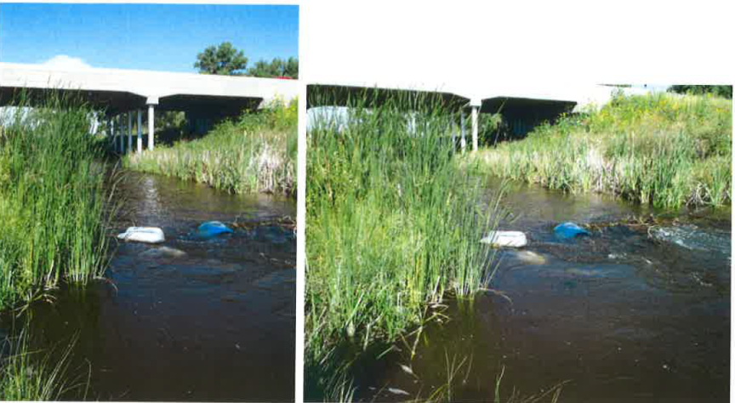

**Niobrara River (Pink Schoolhouse)**- at bridge crossing (south of schoolhouse), anchored in the middle of the stream, attached to green T-post  
42.43275, 103.60146

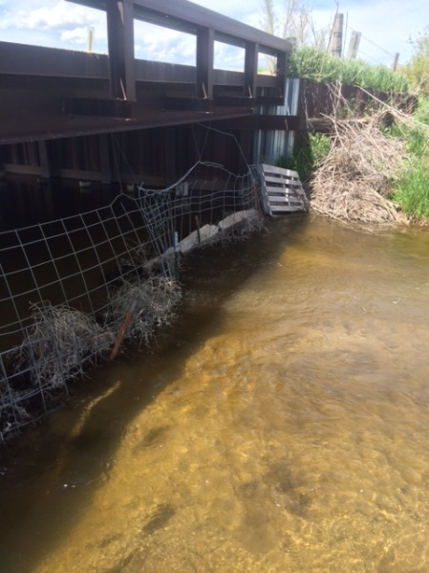

**Pine Creek (South**)- 357th Trail road crosses creek. North of road, west side of creek, 15ft north of electric line marker.   
42.381046, 102.448164  
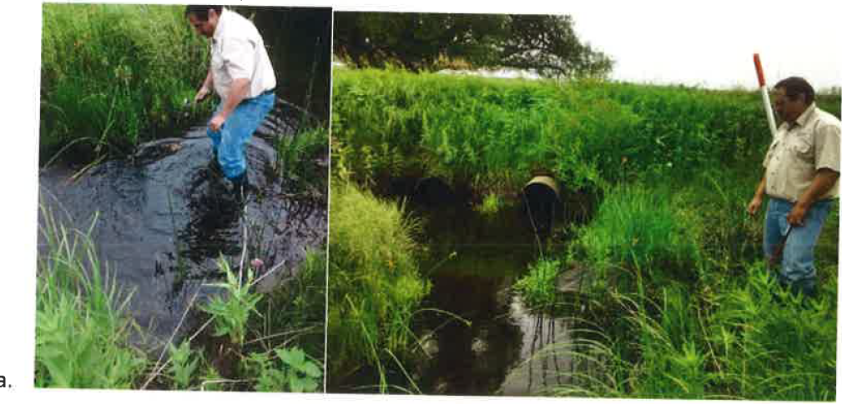

**Pine Creek (Middle)**- west side of road, north side of stream, just before cement. Highway. 42.428241, 102.44154

0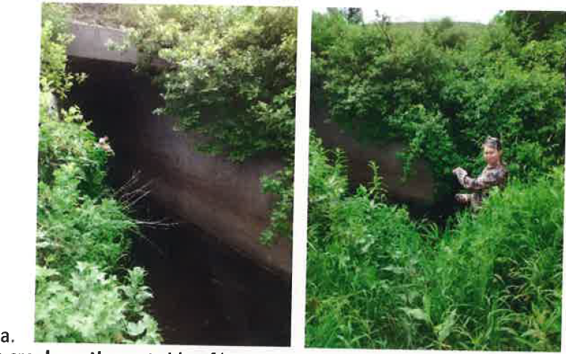

**Pine Creek (North)**- east side of hwy south side of stream, top of pool above culvert. 42.486374, 102.437796

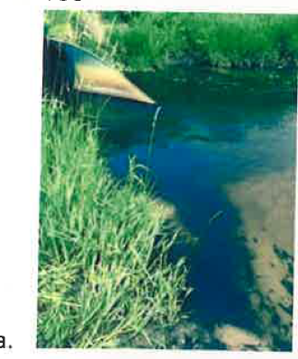

**Spottedtail-**  Tottenhof property, east side of stream, logger cable attached to green steel post where fence hits east side of stream.  
41.94065, 103.83301

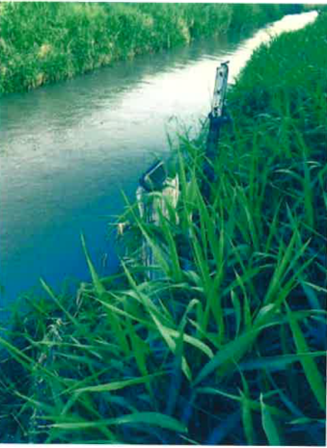

**Soldier Creek (Middle Fork)**- above tree dam in middle of channel, under fallen tree, stake in bank on west side of stream, rebar stake as anchor  
42.69777, 103.57796

**Sowbelly (Harrison City Park)**- far side of creek, approx.. 50 yards down fence line from parking lot and tucked under exposed rocky face.  
42.73498, 103.84031

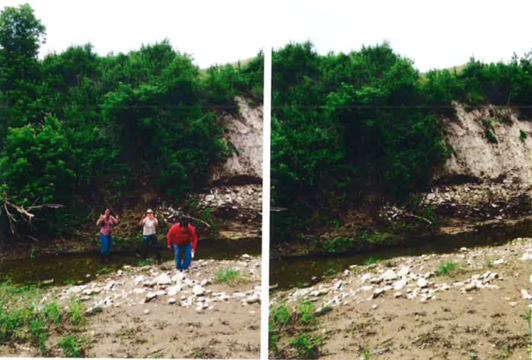

**Squaw Creek**, on Ponderosa WMA, south side of bridge- east side of stream, wood posted used as an anchor  
42.63177, 103.31649

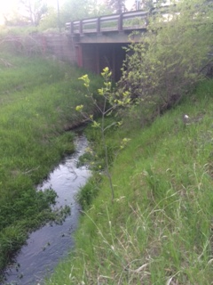

**White Clay Creek**- west side of road, below culvert, attached to tree  
N 42.61698, W 103.34240

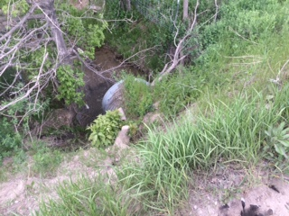

**White River (Andrews)**- Road crossing south of mailboxes on west side of road, next to culvert, stake is on roadside.  
42.63017, 103.73547

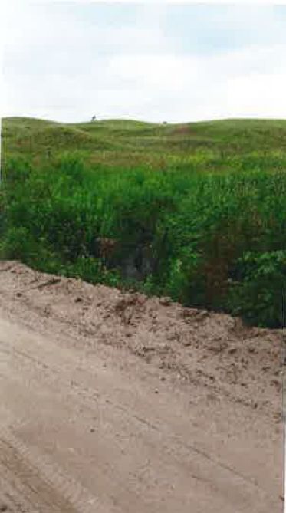

**White River (Swinging Bridge)**- logger located on northeast side of bridge, underneath. (Moved directly across the stream from original position)  
42.65258. 103.47696

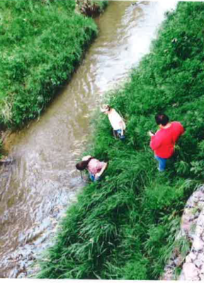

**White River (Glen)**- logger located in Fishing Access site, adjacent to access parking lot. Large cottonwood northeast corner opposite site of stream view when standing at logger location.  
42.60549, 103.59088

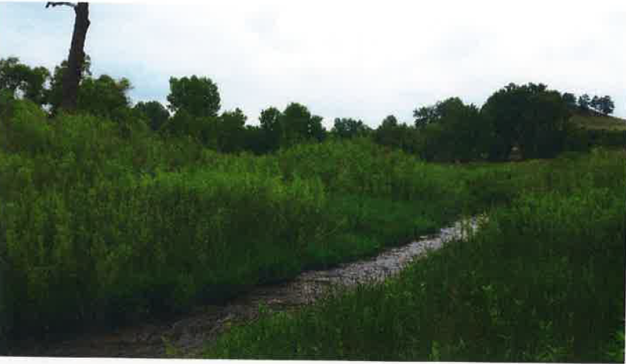

**White River (Between Ft. and Golf Course)**- attached to bank side on west side of river, south side of highway, near bridge overpass in between ft. rob property and golf course  
42.67861, 103.43024

